**Cloning a GitHub Repo (Using GitHub Desktop)**

1. Open the GitHub Desktop application
2. Go to File -> Clone Repository

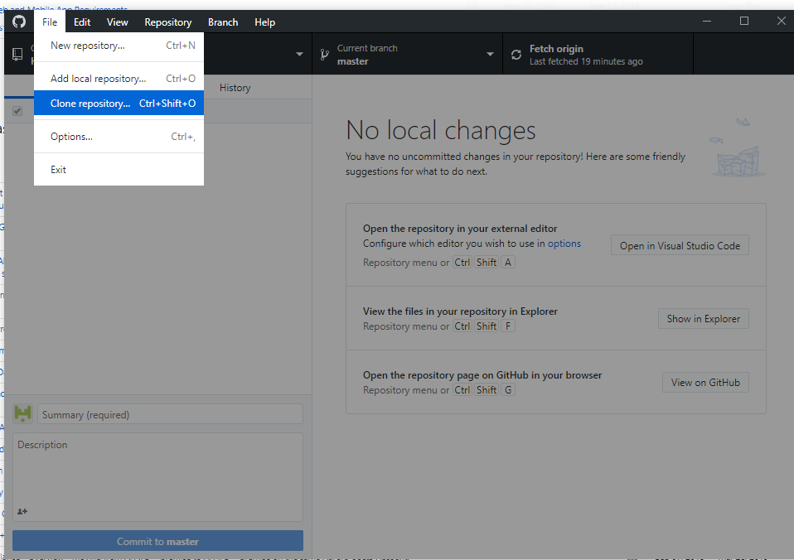

1. Click the URL tab
2. In the ‘URL or username/repository’ field, enter repo URL: <https://github.com/JordanEdmondson/HolyPirates>
3. Gets a bit weird here, but in the ‘Local Path’ field, it will suggest a file path. When I was testing, I actually had to go and create a file in that file path externally, and then copy and paste it into the ‘Local Path’ field.
4. Click ‘Clone’
5. This should pull the repo that is hosted on GitHub on to your machine to the file directory you specified in the ‘Local Path’ field
6. Once you’ve got the repo cloned, you can open the Local Path via the ‘Show In Explorer’ button

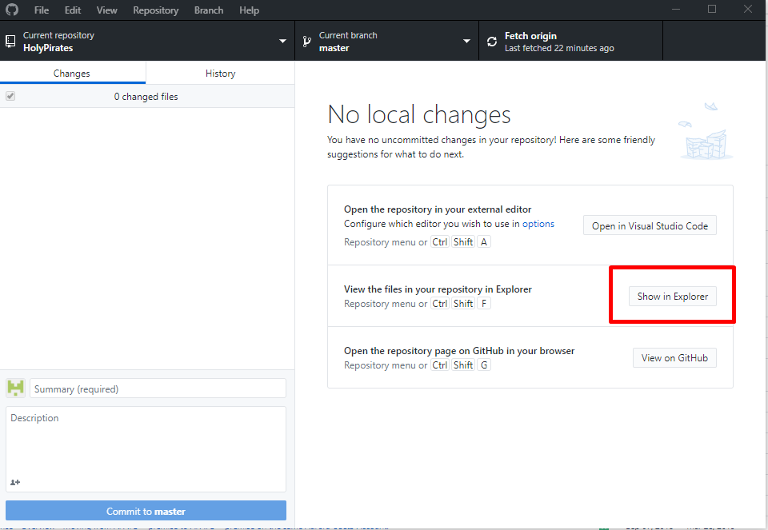

1. Drag all the files you want to upload into that folder
2. Any new files in the folder will automatically be picked up by GitHub
3. Click Commit to Master

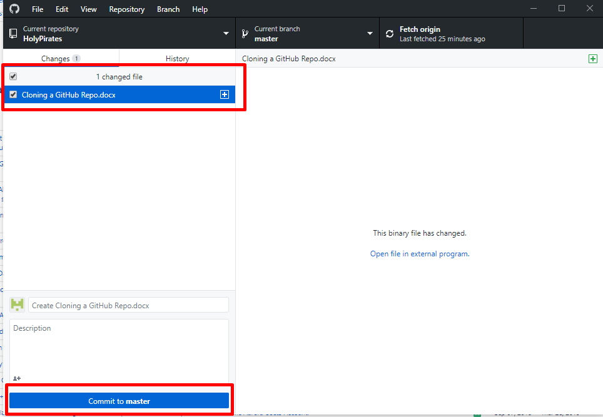

1. Click ‘Push Origin’

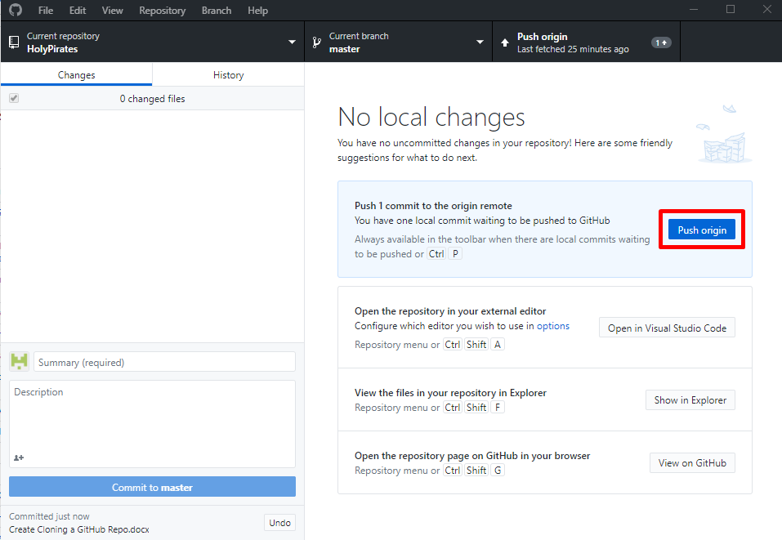

1. All done ☺ You can verify that changes have gone into the group repo by clicking on the ‘History’ tab (Next to the ‘Changes’ tab), you should see your update there at the top of the list ☺